DT – WALT: generate ideas through drawing  What is your dream job? Can you design the uniform that you would need for your profession?  Challenge: What materials would it be made from? What accessories might you have? What colours would you use?  Challenge:  Can you explain why you chose each part of your uniform? |  | History – WALT: understand how TV has changed over time  How has television changed over time? Think about how we watch programmes and films now. How do you think your parents watched programmes when they were younger? How did you grandparents watch programmes? Challenge: Can you carry out an investigation and interview different members of your family to find out if they had a television growing up and what it was like? You can record this through drawings, diagrams or sentences.  Challenge: Can you explain why it is important to not have too much screen time?
Completed on: |  | Completed on:
English – WALT: use a capital letter for the personal pronoun ‘I’  Write a diary entry of what you have done today.  Challenge: Remember to use:  - ‘Dear diary’ at the start  - Capital I in your sentences.  Challenge: Check your work, have you used capital letters, full stops and finger spaces? |  | English – WALT: choose vocabulary to describe a setting  Imagine you are in your local park. What adjectives can you think of to describe where you are? What can you see, hear, feel, taste and smell?  Challenge: Can you write a list of adjectives for your setting?  Challenge: Can you use your adjectives in a sentence?
Completed on: |  | Completed on:
Maths – WALT: understand the link between addition and subtraction  This half term we will be looking at addition and subtraction to 20. Using your number bonds, create as many related facts as you can for numbers to 20.  8-5=3  8-3=5  5=8-3  3=8-5  5+3=8  3+5=8  8=5+3  8=3+5  Example.  8  5  3 |  | Maths – WALT: to use a number line to subtract.  This half term we will be learning to subtract numbers that cross 10. We will be doing this using number lines and understanding how to subtract by counting backwards on a number line.  Pick a starting number on your number line and subtract another number. Use the counting back method to help you find your answer.  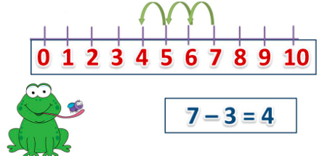
Completed on: |  | Completed on:
Computing - WALT: practise your typing skills  Log into Purple Mash on a device. Complete the homework 2Do’s. Can you practise your mouse skills? Challenge: Can you practise your typing skills? Can you create a digital story on Purple Mash and hand it in?  Challenge: Can you continue to practise your typing skills on 2type on Purple Mash? |  | PSHE – WALT: understand the importance of a balanced diet  Can you write a recipe that has ingredients for a healthy meal?  Challenge: Can you explain why it is important to eat a balanced diet?
Completed on: |  | Completed on:
Art – WALT: use natural materials to create an image  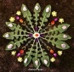  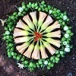  Go on a walk around your local park. Challenge: Can you use natural materials to create an image of a plant e.g. a tree or a flower? Challenge: Can you use sticks, rocks, petals, leaves, earth, mud etc. |  | RE – WALT: understand Christian beliefs  Can you create a fact file about Christians? What do they believe? Challenge: What celebrations do they take part in? What are some important traditions?  Challenge: Can you explain why it is important to learn about other religions?
Completed on: |  | Completed on:

