Thursday 8th January 2026
Dear Parent/Carers,
Year Six Homework
For the remainder of the year, the children in Year 6 will be set homework for English and Maths online using their SATs Boot camp login. This is to go over any curriculum objectives that your child may need support on. Please feel free to revise any topics and do not hesitate to contact the Year 6 team if you need support with accessing or completing the homework.
To log on please go to the following link:
www.yearsix.co.uk
Your child’s username and password has been given out, however please contact the Year 6 team if you require it again.
On the main dashboard please click revise where you will see the screen below. Your child’s teacher will tell your child which sections to revise each week. This will be a combination of maths and grammar.
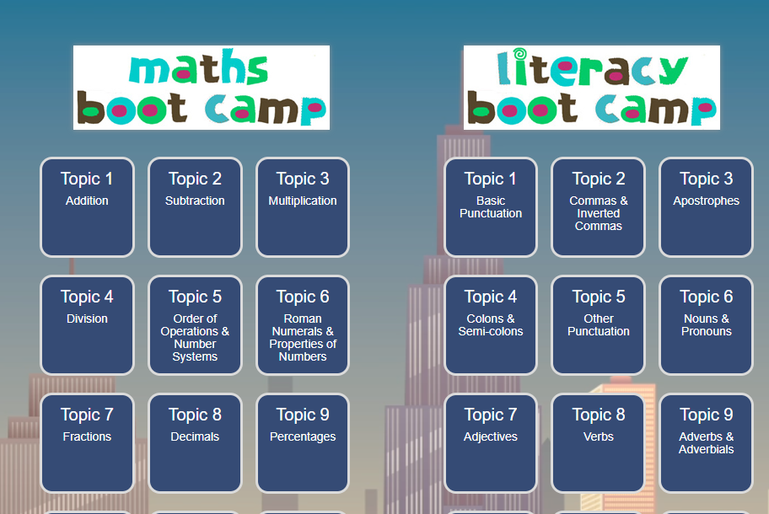



After you have watched the videos, please click on ‘test yourself’ where the children will be able to assess how much they now know. Your child’s class teacher can see which areas they have revised and where they may need further support. We encourage the children to practise past SATs questions in order to become familiar with the wording and types of questions that they may see in their assessments.

Reading & Spellings
Please ensure that your child is reading 3 times a week and this is recorded in their Reading Records. Reading Records will be checked on a Wednesday just like the homework.
Spellings will continue to be stuck into the homework books as usual.

Thank you for your continued support.
Kind regards,
Miss Haynes & Mr Bushnell-Ewers

Week | Focus- Maths
1 | Topic 7- Fractions
2 | Topic 11- Measurements
3 | Topic 23- Ratio
4 | Topic 8- Decimals
5 | Topic 9- Percentages
6 | Topic 10- Equivalence
7 | Independent- choose a topic that you have found tricky this half term and revise it.
Week | Focus- Literacy
1 | Topic 1 and 2- Punctuation and Commas
2 | Topic 4 and 9- Semi-colons and colons, adverbs and Adverbials
3 | Topic 12- Clauses and Phrases
4 | Topic 18- Standard English
5 | Topic 11- Types of sentences
6 | Topic 3 and 4- Apostrophes and Other Punctuation
7 | Independent- choose a topic that you have found tricky this half term and revise it.

